**Reading File From CSV**

**Reading File from Excel**

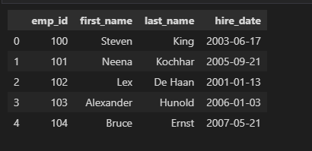

**Reading Data from JSON**



**Reading Data from Database**

